Shabbos Stories For
Parshas va’eschanan 5786
Volume 17, Issue 46 11 Menachem Av/July 25, 2026
Printed L’illuy nishmas Nechama bas R’ Noach, a”h

An Identical Condition
From the Desk of Yerachmiel Tilles

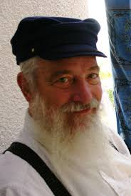
Yerachmiel Tilles

Mr. Segal stepped outside for his regular evening walk. Since he had left the hospital after his heart attack, this was his only daily physical exercise. On his way, he met an old friend, Rabbi Shlomo Greenwald, an elder Lubavitcher Chasid in Eretz Yisrael. They began to talk. Mr. Segal was very depressed by his medical situation, and did not believe he would ever really recover from it.
Rabbi Greenwald tried to cheer him up and give him hope, but to no avail. Seeing that his words were having no effect, Rabbi Greenwald recommended to Mr. Segal that he write a letter to the [Lubavitcher] Rebbe. Mr. Segal was an observant Jew, and had great respect for the Rebbe’s greatness in Torah and his activities on behalf of Judaism and the Jewish people around the world. But writing to him about his health issues?
“Why should I write to the Rebbe all of a sudden”, he asked. “when I was healthy and everything was fine I never wrote to him, and now when things aren’t going well for me I should write to him all of a sudden? Anyway, how can the Rebbe actually help me with medical problems?”

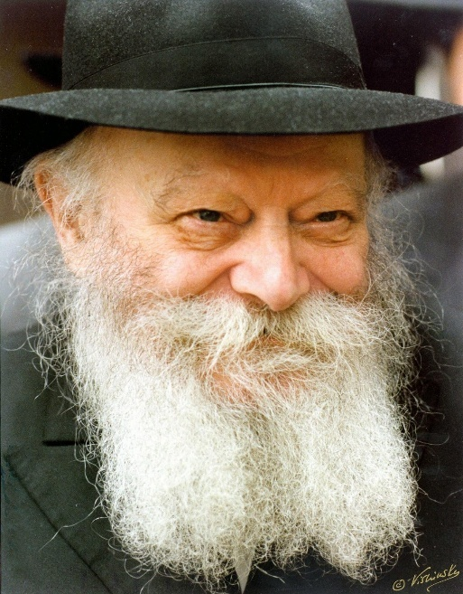

Rabbi Greenwald tried to convince him, mentioning mutual friends and acquaintances that had been helped by the Rebbe’s advice and Berachos, but Mr. Segal remained resolute in his refusal. Rabbi Greenwald then gave it on last try “what if I write to the Rebbe about your situation and ask for his blessing on your behalf?”
This offer Mr. Segal couldn’t refuse. He agreed for Rabbi Greenwald to write to the Rebbe, but told him that he wishes to add a few words of his own at the end of the letter. Rabbi Greenwald wrote the letter and gave it to Mr. Segal, who wrote these few words at the end: “Rebbe! My pains are unbearable! Please pray for me that I should die quickly and painlessly.”
The letter was mailed overseas, and after three weeks a response from the Rebbe arrived. The Rebbe had handwritten under his ‘plea’ 3 words: “Bedikas mezuzos b’bayis” -- “Check the mezuzos at home.”
The immediate impact of the Rebbe’s answer was profound: “I went over to the mezuzah and removed the nail attaching it to the door. As I removed the nail, I felt as if a nail had been removed from my heart as well!” He gave the mezuzah to Rabbi Elimelech Kaplan, the Rav of Shikun Chabad in Lod, to check.
The Rav opened the mezuzah, examined it carefully, and looked up at Mr. Segal. The Rav again looked down at the mezuzah, and then looked up at Mr. Segal once more.
“My dear friend”, he said, “you and your mezuzah suit each other perfectly: you both have the same illness, a severe heart condition”.
Mr. Segal was confused; e thought the Rav was joking with him. How could a mezuzah have heart problems? The Rav showed him the mezuzah and explained: “See here, in the verse, is ואהבת את ה' אלוקיך בכל לבבך ובכל נפשך ובכל מאודך
“The word Le’vavcha (your heart) is completely erased.”
The Rav immediately provided him with a new, kosher mezuza to replace the one on his front door, and more mezuzahs for the other doors in his house. Mr. Segal hurried home to put them up. When he woke up the next morning, he got dressed and told his wife that he’s feeling well, and so he was going to shul for Shachris (Morning Prayers) and then off to work.
“What?” his wife exclaimed, “You have a serious heart condition! If you exert yourself like this, you’ll find yourself back in the hospital. Who knows what will be then!”
The story of the unkosher mezuzah didn’t convince his worried wife;, she insisted that her husband needed to go to a doctor for an immediate checkup, expecting that to disprove his claims. When the doctor saw a healthy-looking Mr. Segal enter his office, he was puzzled. This was a patient that usually showed up when he was experiencing serious problems.!
The doctor listened to Mr. Segal’s story extraordinary story. He reacted with skepticism, and initially objected to doing scans that he thought were unnecessary. But after the couple begged him to do the scans so that they can achieve some clarity, he acceded. An hour later, the doctor received the results of the tests. He studied the papers in front of him, looked up at Mr. Segal, looked back down at the papers, and looked back at Mr. Segal disbelievingly.
The doctor’s strange conduct reminded Mr. Segal of the way the Rav had looked at him and his mezuzah. The doctor then began to read out the results: “Your first tests three months ago showed that your situation was very severe. But today’s tests show conclusively that your heart is now completely healthy. It’s as if you have been born anew!”

Source: from the English translation of Yahalom Shel HaRebbe (“Diamonds of the Lubavitcher Rebbe”), story #20, in the name of Rabbi Binyomin Klein, z’l, one of the Rebbe’s secretaries.

Reprinted from the Parshas Korach 5786 email of KabbalaOnline.org, a project of Ascent of Safed in Israel.
What is Really Important?
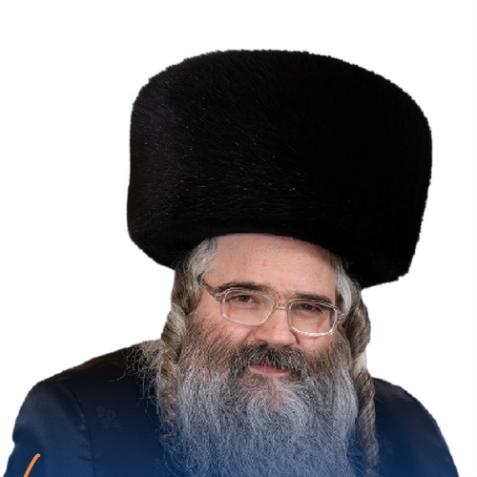
Rabbi Avrum Mordche Malach

Just like a drop of machloket or lashon hara can have disastrous unintended consequences, so too a small positive interaction can become something great. R’ Avrum Mordche Malach shares a story about a regular man who lived in Yerushalayim. Every morning, he would pray vasikin—earliest time to pray Shacharit, eat some breakfast, go back to sleep for a little. After. he would then wake up in time to send his children off to the school bus with a hug, kiss and wish them a good day at school, and then he would drive to work.
It happened one morning this man overslept, and he was running late. His boss wanted everyone to be in early because of a meeting. He rushed to work without giving his kids their goodbye hugs and kisses.
On his way to work he gets a call from his house phone. It’s his son. “My bus is coming soon. You left, and you didn’t give me a hug.” The father explained that he had a big meeting he had to get to, and he would make sure to be there tomorrow. After some silence the boy said, “Okay,” and hung up.
Right before the bus came, the father’s car pulled up. The son was surprised. The father explained, “Listen, I couldn’t stand to hear the pain in your voice when we ended the phone call. I had to hug you.” He wished his son a good morning and a great day at school.
Years later at the son’s last sheva brachot, the boy shared how this specific incident had such an impact on his life. Later, the father stood up to speak. “You know, now that I think about it. I totally forgot that story, I’m thinking to myself, it has been about thirteen years since then. My child remembers what I did for him. What do you think are the chances that the boss remembers I came late that day to work. Zero. He does not remember. That day I was focusing on what I thought was important, being on time. Thirteen years later, I realized that is not what is important. I was focusing on the now, and not the future.

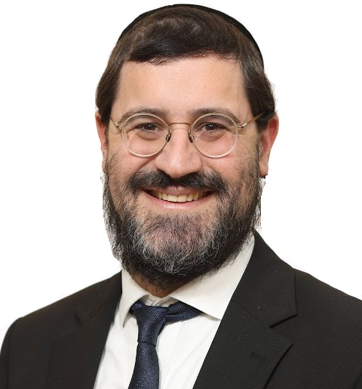
Rabbi Avi Wiesenfeld

Rabbi Avi Wiesenfeld shares that many astronauts that return to earth describe their trip as life changing. From on earth mountains appear massive, countries seem enormous, people spend their lives fighting about land, status and power. From space, none of that is visible. Countries’ borders and divisions disappear. What seemed so overwhelming and powerful are tiny from a spaceship. The astronauts’ perspectives on what is important shifted.
When we are frustrated with someone who inconvenienced or wronged us, we are stuck on ourselves and on the now. We are feeling hurt right now, and all we can think about right then is how bad the other person is. We fail to see the bigger picture, and often we spiral by lashing out or venting to others instead of resolving it with the person directly. We must strive to focus on what is important. Our relationships and our dignity are more important than getting even, jealousy and spite. Our mental energy should be future oriented instead of stuck on one person or one wrongdoing. Ask yourself, how do you want to spend your life?

Reprinted from the Parashat Korah 5786 email of Jack E. Rahmey based on the Torah teachings of Rabbi Amram Sananes.
The Legacy of Rabbi Mendel Futerfas zt"l

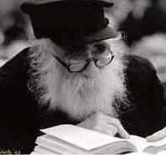

When Reb Mendel came to Siberia he went up to the officer and said, "I want you to know that I am not going to work on Shabbos. If you think because I am lazy, I am willing to work all Motzaei Shabbos and Sunday." When the officer saw that he was so determined and sincere he was allowed off from working Shabbos.
When asked about his time in Siberia, he replied, "they were the most inspiring days of my life." He continued to explain "throughout my life, I always felt a battle between the material and the spiritual. In the labor camps, there was no battle. My life was all spiritual. All I had to do was learn Torah and daven. Of course we had to work!
“In one camp, my job was to care for a herd of pigs. I had to begin at 4:00 am and did not finish until 6:00 pm. In the winter, it was so cold that once the straps of my Tefillin froze. When I began to unwind them, they cracked. It was hard and crushing work, but only physically. My soul was free. There was nothing holding me back. All my energy could be focused on prayer and study."
He was asked if he had any Seforim?
"Seforim?! The Russians would allow us Jewish books to study from? So how did I study? I would picture the cheder I attended when I was a child. I would sit in the third row. I remembered the table at which I would sit, the Seforim that were placed on it. To my right sat my friend Berel, and to my left my friend Zalman. Yossel sat in front of me.
“I remembered their faces, the games we would play, the secrets we would tell each other. I remembered the Rebbi, tall, with stern eyes, but with a warm and loving smile. I would picture him and the classroom in my mind. The scene was so vivid that I could actually hear the melamed speaking, "Shnayim ochazin betallis... If two people are holding on to a garment, and one of them says it is entirely mine and the other says it is entirely mine..." (Bava Metzia 2.).
“I would listen, and concentrate to record his words in my mind. Soon he had taught me a page of Talmud. I then shut off the picture of the cheder and began to review the page that I had just learned. After a time, it was committed to memory. Then I returned to the Cheder to learn another page of Gemarah. In this way, I learned many chapters of Gemarah and a good part of Tanya.
In his later years Reb Mendel was a Mashpia in Chabad Yeshiva. In order not to sleep alone at night he asked two boys to come and sleep with him. The two boys were very excited and came over at ten o'clock to Reb Mendel's house. He offered them a drink, shared with them some Divrei Torah and then said that it's time to say Krias Shema. The boys said Shema and went to sleep. Around 2 am one of the boys woke up and heard quiet weeping. He jumped out of bed and went do the door of Reb Mendel's room. He looked through the key hole and saw Reb Mendel holding a Siddur. He was still before saying Shema. He was saying the part before, 'Hareini Mochel' - The paragraph before Shema that a person forgives everyone who angered or antagonized them.
He was busy repeating the same words over and over and bursting into tears. The boy quickly went back to his room and woke up his friend that he shouldn't miss such an awesome sight. They stood watching quietly for about half an hour and then they were too tired and they went back to sleep. They had no clue how long this went on for.
On Shavuos they got together and had a Hitvaadus. Reb Mendel had drunk a lot so one of the boys took the opportunity and asked Reb Mendel what it was all about. Reb Mendel answered with such a simplicity, "when I say that I forgive, that means I am a somebody, so much so, that someone hurt me. Who am I? Who do I think I am? I am a nobody!" And he started crying uncontrollably. Chabad is known for their Hitvaadus and Fabrengen. (Getting together to share Divrei Torah and sing inspiring nigunim, songs.)
Once at a Hitvaadus, Reb Mendel said, "even Noach knew that the first thing one needed to do after the Mabul was to drink a Lechaim. Therefore, he took branches of vines into the Teiva - ark, in order to plant them after the Mabul and grow grapes."
"If so," asked Reb Mendel, "how could such a tragedy happen as the Torah tells us with Noach becoming drunk and his son Cham behaving so inappropriately?" "The answer is very clear, that's what happens when one drinks on one's own. 'Lechaim' one drinks together!"

Reprinted from the Parshas Shelach 5786 email of Inspired by a Story by Rabbi Dovid Caro.

The Chofetz Chaim’s Bitachon and Reliance on Hashem
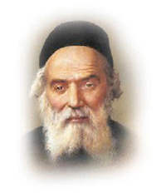
During the First World War, the Chofetz Chaim escaped with his students from Radin to Samilovitz. (Like many Yidden at that time, they were trying to keep away from the front, where the war was being fought.) When the front reached Samilovitz, the Chofetz Chaim and his students had to escape further away, and they settled in Shumietz, which is in the Mohilev region of Russia.
In Shumietz, Cossacks would routinely come to the yeshiva to search for bachurim who had evaded the draft to the army. Since there were many such bachurim, it caused much tension and fear whenever the Cossacks came.
In the sefer החפץ חיים חייו ופועלו (p.113), it states the following: Once, when they were searching for the bachurim who evaded the draft, the Chofetz Chaim became very afraid, and he was worried the entire day. He fasted that day, and by nighttime, the Chofetz Chaim felt very happy and optimistic.
He called for his son-in-law, Reb Tzvi, and told him that he found chizuk from the Torah. When the people of Sodom asked Lot to send out the guests so they could harm them, Lot pleaded with them not to harm his guests. He said (Bereishis 19:9)
רַק לָאֲנָשִׁים הָאֵל אַל תַּעֲשׂוּ דָבָר כִּי עַל כֵּן בָּאוּ בְּצֵל קֹרָתִי , "to these men do nothing, because they have come under the shadow of my roof."
Lot felt responsible for taking care of them because they had come to his home. The Chofetz Chaim said that Lot wasn't the greatest tzaddik when he lived in Sodom, but he understood the principle of taking care of his guests. They came to him, relied on him, and he had to protect them. Certainly, if we go under Hashem's shade and rely on His protection, Hashem will not abandon us!
Indeed, throughout the period they were there, not one student was drafted into the army. Initially, the Cossacks brought some of the bachurim to their commander. But when the commander heard about the greatness of the Chofetz Chaim, he freed all the bachurim.
There is a mashal of someone helping an old man walk across the street. The old man can't walk on his own and can hardly stand on his own, so he leans on the young man as they cross the street. Then the young man suddenly slips from under the old man's arms and rushes off to where he must go. The old man falls to the floor.
Everyone understands that something terrible happened. How could one be so callous and allow the old man to fall to the ground?
Similarly, when we trust in Hashem, Hashem will help us. Hashem won't allow the people who trust in Him to fall. This is alluded to in the pasuk (Devarim 32:4) "a faithful G-d, without injustice He is righteous and upright." "Hashem is righteous and upright," and He won't allow those who rely on Him to fall.

The Power of a Heartfelt Tefillah
By Rabbi David Ashear

One of the greatest gifts Hashem has given us is the ability to speak to Him. A person can turn to Hashem at any moment, from any place, and ask for His help.
Sometimes we pray for ourselves, and sometimes we pray for others. When we pray for others, we may never get to see what our tefillot have accomplished. We say a few words, shed a few tears, and then move on with our lives. But we must know how valuable every tefillah is. Sometimes Hashem allows us to see just how powerful one heartfelt tefillah can be. A rabbi related the following story, which he heard directly from the man to whom it happened.
One evening at around 7:30 in Bnei Brak, there was a knock at a man's door. Anyone with a large family can imagine what a home looks like at that hour. Children everywhere, the house bustling, everyone busy.
He opened the door and saw a man standing there.
"Mazal Tov," the visitor said. "I just had a baby girl."
"Mazal Tov," the man replied, but he was confused. He barely knew the person standing at his door and couldn't understand why he had come.
The visitor then asked if he could come in for a few minutes.
After sitting down, he said, "I want to take you back about nine months, to Simchat Torah.
"I had been married for eighteen years without children. Most of the time I managed, but Simchat Torah was especially painful for me. Everywhere I looked, fathers were dancing with their children. I felt I couldn't take it anymore. I decided I was not going to pray in my regular shul that day. Instead, I went to a different shul where you happened to be praying.


Rabbi David Ashear

"I was sitting by myself there, and you came over to me and asked why I was sitting. You then told me to gather up my children and go dance with everyone.
"I answered you sharply. I told you that I had specifically come to this shul because I couldn't bear watching everybody celebrate with their children when I didn't have any. I felt like you had poured salt on my open wound.
"You may not have realized it, but after our conversation, I watched you walk over to the Aron Kodesh. You started crying out to Hashem, saying, 'Ribbono Shel Olam, why did I just say that? Why did I speak that way? What did I do? Please help this man. Please send him a yeshuah.'"
The man had no idea that anything had come from that tefillah.
The visitor continued, "You didn't know my name. You didn't know my story. You knew nothing about me. You simply stood there and begged Hashem to help me, with tears streaming down your face.
"Before Sukkot, we had just received results from a major specialist telling us there was virtually no chance we would ever have children. But from Motzaei Simchat Torah until now, everything changed.
"Today, after eighteen years of marriage, my first child, a baby girl, was born. You are the very first person I came to tell. I wanted you to know that your tefillah helped bring this yeshuah."
Look at how valuable even a short tefillah can be. A person may think that a few words spoken to Hashem cannot possibly make a difference, but they can.
This man wasn't even asked to pray. He didn't know any details. He simply felt the pain of another Jew. And when he realized that he may have added to that pain, he ran to the Aron Kodesh and cried out from the depths of his heart. Nine months later, Hashem showed him what those words accomplished.
We never know what one sincere tefillah can accomplish. We never know how much can be achieved when we pray for another person with genuine care. Every tefillah matters. Every tear is counted. And sometimes Hashem allows us a glimpse into the incredible power of our words.

Reprinted from the June 17, 2026 email of Living Emunah.

For the Sake of Truth
By Yehuda Azoulay

Rav Yehudah Sadkah tested many talmidim in Yeshivat Porat Yosef in Yerushalayim on specific sections of the Shulhan Aruch and Gemara, with the goal of their obtaining Semichah (Rabbinical ordination). Once, when Rav Yehudah was ready to issue the standard semichah degree to a student, he advised him to visit the scribe who served as the yeshivah’s sofer to have him write up and personalize the official document. The student returned the following day for the Rosh Yeshivah’s signature.
All ordination certificates bore the signatures of two of the yeshivah’s foremost Roshei Yeshivah. In his humility, Rav Yehudah suggested that the student should first have Rav Ben Sion Abba Shaul sign it and he would follow suit. The student visited Rav Ben Sion, who graciously signed. The next morning, he returned to Rav Yehudah, but to his dismay, the Rosh Yeshivah glanced at the document and refused to sign it.
“Pardon me a thousand times over for all the inconvenience I am putting you through,” Rav Yehudah said. “However, I am sorry to tell you that I cannot sign a document which is not wholly truthful. You will note that the date appearing on the certificate is incorrect. The text reads: ‘Written and signed this twenty-sixth day in the month of Av…’ when in reality, today is the twenty-seventh day of Av.”

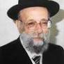

Rav Yehudah then related a very similar anecdote about Rav Ezra Attiah.
“A student once appeared before Rav Attiah to obtain his signature on an important proclamation issued by many of the hachamim of Yerushalayim. The incident took place when Yeshivat Porat Yosef was still in the Old City, in close proximity to the Kotel Hama’aravi.
The meeting between Rav Attiah and the student, however, was held in the New City. While reviewing the document, Rav Attiah noticed that the last line read: ‘We, the undersigned, here in the Old City…’ Noticing that line, he refused to sign the document, as it did not reflect the truth; at that moment they happened to be in the New City. However, in view of the urgency of the matter, Rav Attiah put on his overcoat and said to the student, ‘Let’s go to the Old City, for the sake of absolute truth. There, I will sign the document, and we can then return immediately.’”
Rav Yehudah’s student fully appreciated his Hacham’s reservations in signing the ordination with the incorrect date. In those short minutes, he had gained a wealth of practical Rabbinical experience, as our Hachamim state, “Attending to a Talmid Hacham is often more beneficial than studying Torah from him.” He returned to the scribe, who changed the date. He then resubmitted it to his Hacham, who welcomed him with great warmth, signed the certificate, and wished him great success in his future role as a manhig eidah b’Yisrael.)
Reprinted from the Parashat Korah 5786 email of Rabbi David Bibi’s Shabbat Shalom from Cyberspace. (Excerpted from the book - “A Legacy of Leaders: Inspiring Stories and Biographies of Sephardi Hachamim.”
“Bad Company”
By Rabbi Joey Haber

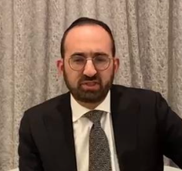

The Gemara (Sanhedrin 93a) tells the story of two false Jewish prophets who lived during the time of the Babylonian King Nevuchadnetzar. The king accused them of prophesying falsely, and decreed that they should be thrown into a furnace. He said that if they were real prophets, then they would miraculously survive, just as three righteous Jews – Hananya, Mishael and Azarya – had previously emerged unscathed from the furnace.
The two [false] prophets argued that the merit of three righteous men exceeds that of just two, and so this trial was unfair. Nevuchadnetzar allowed them to choose a third person with whom to be cast into the furnace, and they selected the tzadik Yehoshua Kohen Gadol, hoping that his merit would protect them.
The three was thrown into the furnace – and Yehoshua miraculously survived, while the two prophets perished. However, Yehoshua's garment was burned by the fire.
Yehoshua was asked why his clothes were burned, whereas Avraham Avinu, when he was thrown into a furnace many centuries earlier, emerged completely unscathed, without even his garments being ruined.
Yehoshua answered that since he was in the furnace together with two wicked people, the fire was given permission to consume, and so his garments were burned. Avraham, by contrast, was thrown into the furnace alone, and so the fire was not granted the power to consume anything.
This story is teaching us a sobering but important truth: when we are in bad company, we get "burned" to some extent. Even if we succeed in "surviving," in maintaining our beliefs and values, we are likely to be affected.

Reprinted from the Parashat Korah 5786 email of Shabbat Shalom from Cyberspace.
Looking for a Minyan
on the Battlefield

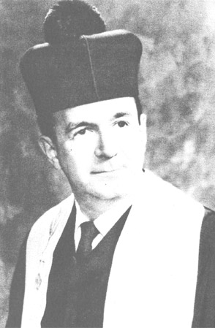
Cantor Louis J Herman, a”h

Cantor Louis J. Herman grew up in Toronto, Canada. His father, Rev. Samuel Herman, had been a well-known Cantor in Montreal and Toronto. A boy soprano, Cantor Louis Herman was a protégé of the world-famous Chazan, Yossele Rosenblatt, and had sung on the famous Maxwell House Coffee Hour on New York’s Jewish Station WEVD. During the 1920’s and 1930’s he sang professionally in Canada and throughout the American middle west and northeast.
When Canada entered World War II on the side of the allies, Louis Herman enlisted in the Canadian Army and ultimately saw combat duty. When he finished his training, young Louis was transferred to Italy. He was promoted to the rank of sergeant and by war’s end, he was assigned to the front, in the midst of heavy fighting.
Throughout the difficult months of the war, Louis kept as many mitzvos as he possibly could. On the day of his mother’s Yahrzeit, despite being many miles away from any shul, Louis wanted to say Kaddish for her. This prayer, however, would require a minyan, and finding ten Jews in the middle of a battlefield in ltaly was not going to be easy.
Louis knew of only five other Jewish soldiers in his unit. Louis approached the army chaplain, who was a priest, and explained his predicament. Louis asked the chaplain if he knew of any other Jewish soldiers in the area. To Louis’s surprise. the chaplain not only knew where he could find other Jewish soldiers, but he also understood the meaning of a minyan. He was happy to be of assistance.
“See that area over there?” The chaplain pointed to a tall observation tower. “That is where our soldiers guard our unit and watch for advancing German soldiers. When they see any activity, they radio the information back to the artillery unit to help us aim our bombs more precisely. There are four Jews who occupy positions in the observation tower. lf you’d like, I can put in a call to them and ask that they come over to our area for your minyan.”
Louis was overjoyed. He would have exactly the ten men required to make up a minyan. The kind chaplain called over and asked if the unit could spare the four Jewish soldiers for a few short minutes. To his great relief, the soldiers were happy to oblige. Louis was able to say Kaddish on his mother’s Yahrzeit with a minyan.
After they finished davening. Louis thanked everyone for joining him and enabling him to fulfill this meaningful personal obligation. The entire group lingered for an extra minute, enjoying the opportunity to pray altogether, even for a short time. As the four soldiers turned to walk back to the observation tower, they suddenly heard a loud explosion and saw a most startling sight.
The entire tower and its contents had been blown up by German saboteurs who had managed to plant explosives at the base of the tower and successfully exploded their charges. Only the four Jewish soldiers, who had just “happened” to be busy doing a very important mitzvah, had escaped annihilation.
Chazal tell us (Pesachim 8b) that “Shluchei mitzvah einan nizokin” - messengers who go to do a mitzvah are saved from harm. Not only do acts of chessed help others, but those very acts can also save us from harm.

Reprinted from the Parshas Korach 5786 email of Rabbi Dovid Hoffman’s Torah Tavlin. Excerpted from the Feldheim book – “For Goodness’ Sake.”

